Bird conservation on working lands: engaging private landowners in solutions that benefit birds and people) - Kelly Srigley-Werner (moderator)

Bird conservation solutions are most effective when they are developed in conjunction with the needs of human communities. When conservation challenges include working together on private lands, considering landowner needs, perspectives, and local knowledge is necessary for the success of management actions. This session will provide insight into how working lands can benefit declining birds and will provide a roadmap for building trust with landowners who bridge the gap between economy and ecology. The first half of the breakout will take participants on a journey of success and overcoming barriers. We will be joined by board members from Partnerscapes, a grassroots movement of private landowners working with agencies, non-profit organizations, and policymakers to collaborate on conservation projects that sustain working landscapes for present and future generations. Delta Wind Birds, an organization dedicated to wetland and migratory bird conservation, will discuss ways to integrate working lands into conserving migrating birds in the southeastern U.S.. Then the U.S. Fish and Wildlife Service’s Partners for Fish and Wildlife Program and Ducks Unlimited, Inc. will discuss the tools needed to build collaborative partnerships. The second half of the breakout will provide species working groups a space to explore their own needs and challenges, with help from the presenters and other experts, and discuss how to start a collaborative effort and solve problems together while balancing the needs of land stewards with the needs of species we are conserving.

Landowner Breakout #1 – Landowner Perspectives/Partnerships

Jason Hoeksema – Delta Windbirds (DW), University of Mississippi

Lower Miss Valley – Important to shorebirds: 500K shorebirds, 27 spp. Limited fall stopover habitat. Temporary wetlands on private lands. Collaboration with Four Winds Refuge (hunting camp). Owners provide habitat in spring without payment.

Question of providing fall shorebird habitat w/o pumping groundwater. Lots of Tailwater recovery ponds have left-over water at the end of irrigation season. NRCS developed recovery reservoirs, so DW approached about running a pilot to create shorebird habitat. NRCS recommended Mr. James Failing as a contact. Tailwater flooding after corn harvest (harvested earlier). Provided a control and experimental design.

Potential benefits expected - Bird habitat, soil conservation and denitrification.

Outcomes of the experiment and pilot: Bird benefits quick and response with large numbers. Sediment retention was high and denitrification was 50% better. Soybean yield actually increased slightly (5%).

Decided to message to other local agricultural producers. Increased to 9 farmers and 10 farm sites. Five whole-field treatments with different flooding scenarios. Mr. Failing acts as outreach champion to farmer peers. Lots of face-to-face time with mutual interactions to understand farm operations and being open about issues or conflicts. Local student has worked to build relationships with farmers.

Farmer concerns about flooding for wildlife (set up 40-50 interviews with farmers to expand project), noting these concerns:

- Interference with duck-hunting leases
- takes time away from harvest and field prep (on rest of farm)
- erodes beds that have been prepared
- stubble drift to interfere with planting
- delays planting
- hardens soil
- “locks up” phosphorus, reducing yield

Some farmers didn’t always flood soon after harvest. Increased outreach to get earlier flooding.

Mr. Failing agreed to answer questions and talk with farmer neighbors. Solve problems together, involve landowners early to hear concerns, demonstrate to others successes.

Questions:

Will work be published? Yes. Manuscripts in preparation.
Incentive program source? Delta Windbirds founded to continue Bird Habitat Enhancement program, which was not keeping up with economic costs. Rate of $100/acre. Private donations and government grants helped through partnering

Kiandra Rajala – USFWS Human Dimensions Team

Partnership Impact Model and Three Phases of Partnership Lifecycle (add diagrams)
Connectivity and Trust is foundational.

Find ways to build on trust through collaborative interactions with local landowners and find local champions. Connect with landowners by learning why their land matters to them and what ideas do they have. Listen.

Once the foundation is built, begin the growth period by engaging and collaborating with more partners and communities. This is where creativity comes into play to find ways to share resources and build a collaborative effort for a bird species or multiple species but also meets the needs of landowners and other organizations. Resources below for more detail:
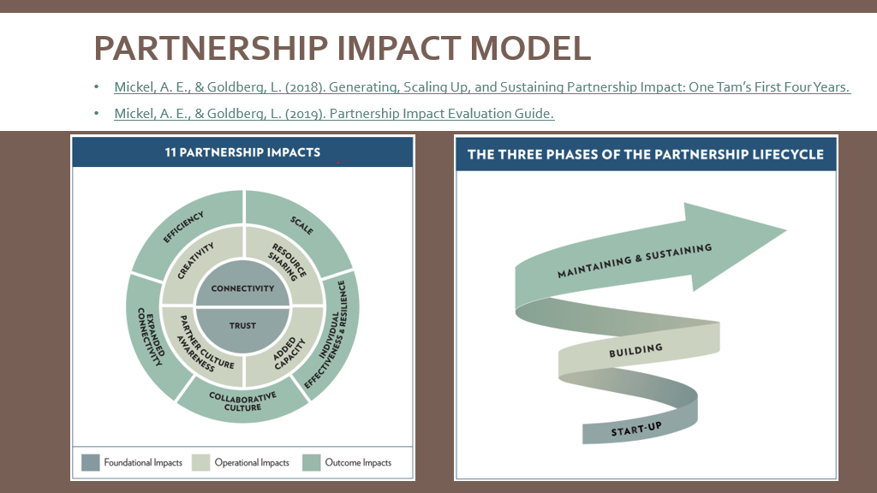

Shelly Kelly – Partnerscapes Board; land steward/Rancher, Nebraska

Sandhills. Executive Director, Sandhills Task Force. Worked for NRCS.

Sandhills = 20 million acres. Largest intact grassland in USA. 90% private lands.

Kelly’s operation: Buy and sell bred cattle for summer and fall calving. Non-traditional in operation, business model. Leases from multi-generational family.

For lease, suggested rotational grazing, noxious weed control (and invasive cedars).

Problems with NRCS because of grazing practices by previous tenant. Went to other county office, had more success. Partners include USFWS PFW, NRCS (other county), and neighbors.

When working with land owners, ask questions. Land owners have a reason for owning it. Important to engage and understand why.

There was a push at one time to plant trees. Nebraska plants more trees than most states. But it is a prairie ecosystem.

Task force working to train on prescribed burning. Culture not used to burning. Need to burn to restore grasses and limit cedars. However, a few cedars, as long as they are controlled are good for calving and winter cover. So need effective management.

Rotational grazing with differential management objectives.

Became aware of a high density of Long-billed Curlew in the Sandhills and pointed this out to her father, who did not realize the population existed. Maintained prairie dogs for burrowing owls. While pointing out certain wildlife on hers and her family’s ranch, she has gotten people to notice and care.

Landowner Breakout #2 – Perspectives from Agencies and Organizations

Dave Walker – Farm Conservation Programs Coordinator, USFWS

Dave gave an overview of linking Private Lands Conservation and the Farm Bill by providing an overview of all conservation funding streams from USDA – Natural Resources Conservation Service and Farm Service Agency

Farm Bill initiated in 1933. First conservation provisions in 1985. Today, 70% goes for nutrition assistance.

70% private lands, 50% of 1.9 billion acres is crop or range land.
Essential tool in the conservation toolbox.

Agriculture Improvement Act of 2018 authorized >$5 billion annually for five years; extended at end of FY2023. Inflation Reduction Act gave another $19.5 billion over five years.

All programs are voluntary for conservation of soil, water or habitat as program purpose or benefit. Either financial or technical assistance for conservation practices. Most programs competitive and projects are ranked.

CRP – Conservation Reserve Program (FSA)
EQIP – Environmental Quality Incentive Program (NRCS)
CSP – Conservation Stewardship Program (NRCS)
ACEP – Agricultural Easement Program (NRCS)
RCPP – Regional Conservation Partnership Program (NRCS)

All Farm Bill dollars will be spent. People have an opportunity to influence USDA decisions at various levels:
National – legislation, practices, ranking tool
State – State Tech Committee, ranking and funding
Local – local working groups, conservation districts

Financial Assistance
Practice and incentive payments
Rental and easement payments

Voluntary programs require effective outreach to target landowners
The right people in the right place for the right reasons
Importance of partnerships stressed to pool resources (funding, practices, staff, messaging)

Wildlife:
General CRP
Continuous CRP
Grassland CRP

Working Lands for Wildlife
Landscape Conservation Frameworks – 4 new as of 2024/25

Big Game Corridors
SE Aquatic

Aron Flanders – Private Lands Biologist Kansas Partners for Fish and Wildlife Program

Kansas – A prairie state. 90+% privately owned
Livestock production important industry and economic driver
Threats to the ecosystem – conversion, invasive species, drought
Lack of prescribed fire and certain grazing practices, wildlife
50% historical wetland loss due to drainage, conversion, sedimentation, roads
invasive species and irrigation reduces surface and groundwater

State-wide grazing coalition
Comanche Pool Prairie Resource Foundation – community-based, landowner-driven
NGO, private; academics; state/federal agencies to technical assistance/permitting

Strengthen partnerships by being present. Participation in local communities is key. “If you are too big to do the small things, you are too small to do the big things.”

Breaking down barriers:
Increase awareness (outreach and education)
Cost prohibitive (leverage funds)
Know what others can bring do to round out conservation practices
Conservation delivery (effective private land owner agreements)
Technical guidance (flexible, innovative, timely, neighbor-to-neighbor)

Recognize landowner partners

Celebrate success and find ways to celebrate landowners with partners

Cheyenne Bottoms/Quivira – invasive species control key to producers

Ducks Unlimited – Mike Randall and Kelsey DeZalia-Jenkins

Delaware/Chesapeake – projects to restore NWR wetland ponds.
Working with the states on projects like retriever training and restoration of agricultural land.

Work with NOAA on fishery recovery in coastal systems.

Work on NAWCA projects. Outreach to private landowners on finding common objectives. Agricultural restoration.

Plant the seed. Be part of the community. Work to stay engaged. Build partnerships by engaging like minded groups and organizations to be a part of the effort to meet objectives by pooling resources (funds, staff, messaging).

USA Rice Partnership climate-smart commodities. Reduces methane emissions by adopting climate-smart practices, such as wetting.

Question topics

Dave W. Inflation Reduction Act USDA funding has a list of practices, including facilitating practices.

Dave H.– Collaboration is key. Question from Private Lands Partners Day “Would you have done this without the partner funding?” Yes, but would have taken a long time.

Steve Jester – Know the funding community as part of providing technical assistance, particularly if request does not fit your organization. Seek expertise of private lands biologists in your region or at the state level (https://www.fws.gov/program/partners-fish-and-wildlife). All 50 states and territories have a Partners for Fish and Wildlife Program Coordinator; and most state agencies have a private lands division – go to your state wildlife agency website.

Question about sharing with landowners the value of their property within the larger landscape context. Always good to eventually work towards informing a landowner where their land value fits in with the larger landscape but not at first unless the landowner leads that narrative. Initially work on understanding and listening and potentially finding ways to work together.
Panel Session: Identifying Human Dimensions Connections and Private Lands Conservation Opportunities

Kelly Srigley Werner (Moderator)
Shelly Kelly (Partnerscapes Board; land steward, Nebraska)
David Haubein (Partnerscapes Board; landowner/ag producer, Missouri)
Mike Disney (State Coordinator Kansas Partners for Fish and Wildlife, USFWS)
Kiandra Rajala (Social scientist, U.S. Fish and Wildlife Service)
Jorge Velasquez (National Audubon Science Director for Latin America)

Connecting with people and building trust is one of the keys to working with landowners on conservation issues. But how do you begin with an approach to reach landowners in ways that benefit both the resource and the landowner. We have asked social science, biological science and conservation delivery practitioners as well as working landowners from Partnerscapes to share their knowledge and experience on ways to develop the best strategies working together for change. Social scientists can help guide you with the appropriate tools for change. Conservation Delivery biologists and biological researchers will provide you with some ideas to get started, and landowners will share their experiences working with conservation agencies and organizations and what made them want to. Key Themes: Building trust, incentive-based actions, rules and regulations, sharing information, appealing to emotions and social influences.

David – Video on Audubon Conservation Ranching program on his ranch (Dade County Missouri Conservation Ranching). David is a row crop producer and also a cattle rancher. Raises certified bird friendly beef through an Audubon program called Conservation Ranching Initiative. Was the first in the nation to be certified through this initiative. His work and effort to improve his land involved Audubon, the Missouri Department of Conservation’s private lands program and the U.S. Fish and Wildlife Service’s Partners for Fish and Wildlife Program
https://audubon.org/our-work/prairies-and-forests/ranching. He explained that he always had the vision but without the help of others it would have taken much longer to get to where he wanted his farm to be.

Shelly – Overview on ranching on the edge of the Nebraska Sandhills. Key issues noxious weeds, including cedars, and moving from year-round to rotational grazing. Trying to introduce prescribed burning. Advice: private lands biologists or anyone interested in working with landowners should work to understand the industry of the landowners they work with.

Kiandra – Human Dimensions. Bridges the gap between research and conservation practice. Works to link social scientists into the practice of conservation. Work collaboratively and find commonality, listen to stakeholders and landowners, commit to the effort to sustain action, understand the scales that people can work from.

Jorge – Works in the Cauca Valley, Colombia. Economic forces have reduced wetlands in this Andean valley. Working with sugar cane producers to incorporate a rice rotation into seven-year production cycle. Developed a set of cost-effective conservation strategies for the valley.

Mike – Loads of partners needed to accomplish wildlife conservation on private lands; Kansas is 98% privately owned lands. Kansas Grazing Lands Coalition is a key partner to pool expertise, solve problems, pool resources (funds, staff, equipment, messaging, etc.).

Question for Shelly/Dave: What was the one thing that resonated with you to engage in conservation?

Dave – Father’s influence and historical view of land change. Saw huge, positive effect of planting warm season grasses on wildlife. Also, great agency people to work with.

Shelly – Also grew up trying to improve their land and operation. Biologists need to relate to how conservation objectives will affect landowner’s operation.

